Why is diffusion at the lungs so effective?

Diffusion- movement of substances from an area of higher concentration to a lower concentration
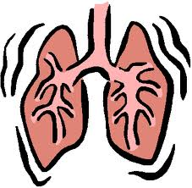
- Thin membrane/ cell wall
- Short distance to travel
- Large differences in partial pressures
- Large contact/ surface area
- Slow blood flow.

