Sports Rehabilitation
Elite sports performers want to recover from injury as soon as possible to minimise fitness losses.
We need to know about
- Hyperbaric chambers
- Oxygen tents
- Ice baths
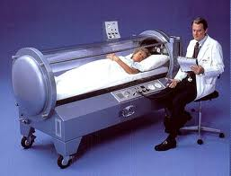
What you need to know?
- What is involved
- Physiological reasons for its use
- Who is likely to benefit
- Does it work?
Hyperbaric Chambers
Originally developed for decompression sickness. Delivers oxygen at high pressure (2 ½ times normal air pressure) 100% oxygen. So performer inspires more oxygen, haemoglobin becomes saturated with oxygen. Oxygen delivered to all areas of the body. Improved blood supply, formation of new cells faster, enhances growth and repair of tissues.
Used to treat a range of injuries
- Soft tissue (muscular) and oedema (swelling)
- Tendon and ligament damage
- Tissue infections
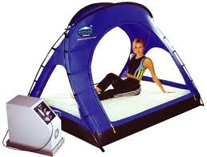
- Compromised immune systems that may have arisen from over training
Oxygen tents/ Hypoxic tents
Used by many famous footballers, usually by endurance athletes that wish to get the same benefits if altitude training. Specialised chambers that regulate the amount of oxygen that you breathe in whilst you sleep. Replicating the low levels of oxygen experienced at altitude, the body responds well by producing red blood cells which then allows the fitness of the performer to be maintained even though training has ceased through injury.
Used to preserve the fitness of athletes rather than treat.

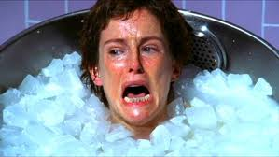

Ice Baths
Ice baths treat both tissue swelling and soreness that occurs following hard exercise and is believed to speed up the recovery process. Immersion in cold water allows controlled constriction of blood vessels surrounding the muscles, effectively squeezing and draining blood and waster products away from the leg. Exiting the ice bath after 6 mins or so then involves a blood rush, this flushes the muscles with freshly oxygenated blood carrying the nutrients and components needed to revitalise the tissue- bit like an oil change!!!

DOMS
Delayed onset of muscle soreness is a term used to describe the feelings of muscle stiffness experienced following exercise (48hrs). More common if new to exercise and eccentric contractions- downhill.
Microscopic tears in the muscle surrounding the connective tissue. Usually goes in a couple of days.

Tips to prevent
- Warm up properly and cool down
- During the training session progress steadily low intensity to high.
- Build up intensity of sessions slowly
- Limit the amount of eccentric contractions performed early on in the training session.

