Skill and Ability Exam questions

- Using examples, explain the difference between cognitive and psychomotor skills
(2 marks)
- Performers need to learn skills in order to take part in physical activity. Skilled movements are learned, economic and efficient- they do not waste energy.
Suggest three other characteristics of skill. (3 marks)
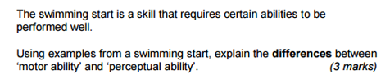

Skill and Ability Exam questions

- Using examples, explain the difference between cognitive and psychomotor skills
(2 marks)

- Performers need to learn skills in order to take part in physical activity. Skilled movements are learned, economic and efficient- they do not waste energy.
Suggest three other characteristics of skill. (3 marks)

