Rational Recreation Sample Questions Mark Scheme – be sure to close the gap with your missing knowledge!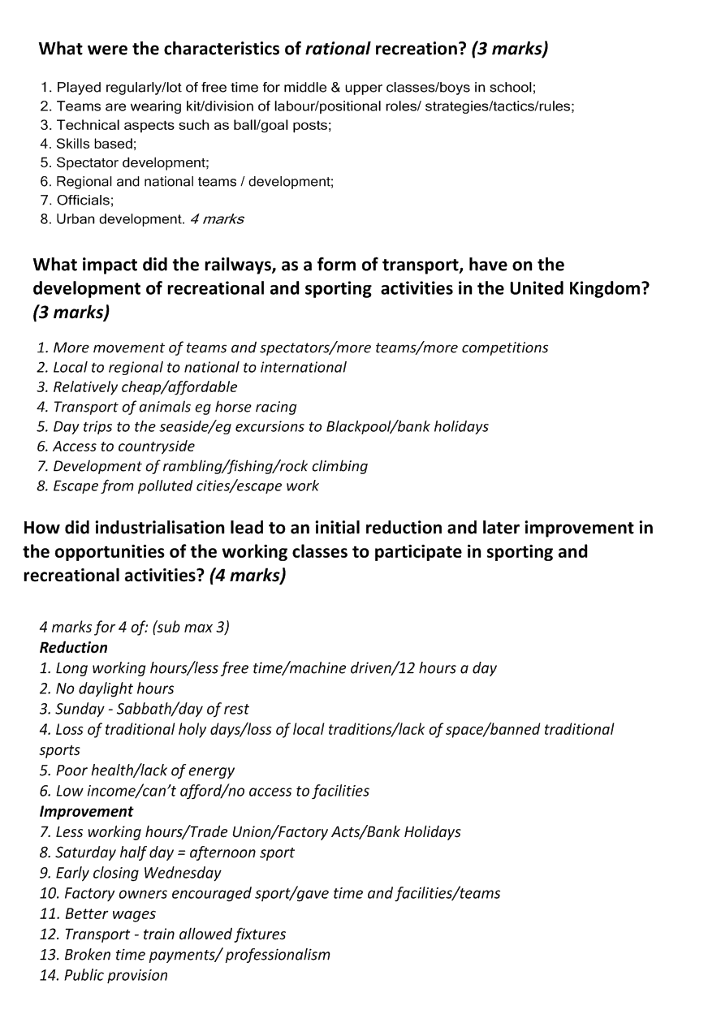

Since the 19th century, how and why did the Church develop leisure opportunities for the British public? (4 marks)
Why
1. Social control / occupy peoples time in acceptable activities
2. Wanted to improve morals of working classes
3. Improve health
4. Tried to make church attractive /recruitment
How
5. Encouraged rational /civilised activities
6. Allowed Sunday school clubs / teams e.g. Everton
7. Boys Brigade / Scouts / Guides
8. Provided facilities e.g. church halls / fields
9. YMCA developed volleyball and basketball
10. Encouraged link between Christianity . military . physical / muscular Christianity
11. Clergy / vicars etc took an active role
12. Services put on for ramblers/ cyclists

Why were the majority of sports rationalised in the 19th century? (4 marks)

1. Society becoming more civilised/manners/less violent;
2. Middle class were in control of society’s values/social control of working
classes;
3. Industrialisation - need for disciplined workforce;
4. Era of social reform/philanthropists;
5. Mass of population needed entertaining;
6. Lack of space meant no room for old popular recreations;
7. Administration needed as more clubs/national governing bodies.
4 marks
Why was participation in sport by the working class delayed compared with participation by the middle and upper classes in the 19th century? (3 marks)
1. Little leisure time/had to wait for leisure time e.g. Wednesday half day/little disposable
income;
2. No facilities of their own/little public provision;
3. Traditional activities lost in urban areas (eg mob football)/legislation/banning;
4. Lack of space for mass of population;
5. No schooling until 1870/then only drill/no sport or recreation focus;
6. Poor health of population/little energy;
7. NGBs/administration was controlled by upper/middle classes. 3 marks
Why did local authorities in the 19th century begin to provide recreational and sporting facilities for their local communities? (4 marks)
4 marks for 4 of:
1. Improve health and fitness of working classes
2. Social reform/social justice/improve lot of working classes/civic
responsibility/equality/use of increased leisure time
3. Prestige of local area
4. Social control/keep people out of trouble/ away from pubs
5. Increased productivity
6. Civilising of society/rational recreation encouraged/middle class values
7. Raised moral of community/spirit

