[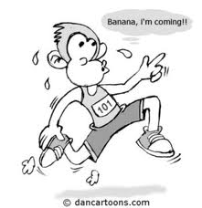](http://www.google.co.uk/imgres?q=monkey+running&hl=en&gbv=2&biw=1152&bih=538&tbm=isch&tbnid=zZHYVoUpU_bCGM:&imgrefurl=http://www.footiewallpapers.com/cartoon-monkey-running-picture-300x309px/cartoonpictures.org%257Cimages%257Ccartoon-monkey-running.jpg/&docid=wMBOQ8DjKfhmmM&imgurl=http://www.footiewallpapers.com/pics/c/a/cartoon-monkey-running-picture-300x309px.jpg&w=300&h=309&ei=bmUcT4HPN42SOpGv0bkL&zoom=1)

**Small increases in lung volume and capacities**

Tidal volume

Vital capacity

Due to increase in strength of respiratory muscles

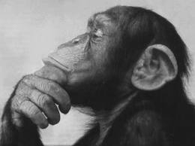

**Improved transport of the respiratory gases**

Increase in blood plasma and RBC’s

Increase in haemoglobin

Blood less viscous

**Improved uptake of oxygen by the muscles**

Training imporves the ability of the muscle to extract oxygen from blood

More myoglobin and mitochondria

= Increased V02 max

**Effects of training on lung function**